SRS
Software Requirements Specification
for
BIT Adaptation for Triplex printers

 | Name | Date
Written by: | Avi T | Last update: 01/08/2011
Approved by:
Version No: | Version 2

- Overview and Objectives
- This requirement aim is to predefine additional BIT tests as part of the Triplex software.
- The basis of all existing BIT tests is Connex500 software version 57.1.
As part of this SRS, some changes in the BIT current behavior are subject for changes.

- Implementation
  - It is required gathering all required messages for the user and show it in one single window at the beginning of the BIT test.
  - Potential actions:
    - Insert the tray. (Relevant only to Office systems i.e. ObjetXXX260)
    - The tray is clear.
    - The machine top cover is closed.
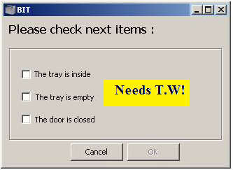

  - When the user selects the tests that needs to be performed, only the required actions will be prompt on the screen according to the real machine state, asking the user to perform action/s.
  - Example: If the user selects only the “Parameter sanity Check”, no message will appear on the screen. (Since “Parameter sanity Check” does not require any axis movement).
    - Seven options for the above message are possible: 1 action (x3); 2 actions (x3) and 3 actions (x1).
    - Messages will be prompt according to the below table (Please refer to the new order of tests according to this table):
Test Name | Tray is inserted (Office machines) Automatic Verification | Tray is clean USER Verification | Top cover is closed Automatic Verification | Pre heat the block and heads?
Sub-Systems Communications | ------------ | ------------ | ------------ | ------------
Data Card communication | ------------ | ------------ | ------------ | ------------
System Info | ------------ | ------------ | ------------ | ------------
Interlock | ------------ | ------------ | V | ------------
Cabin temperature | ------------ | ------------ | ------------ | ------------
Heads EEPROMs | ------------ | ------------ | ------------ | ------------
Head Voltages | ------------ | ------------ | ------------ | ------------
Head/Block heaters | ------------ | ------------ | V | Yes
Parameter Sanity Check | ------------ | ------------ | ------------ | ------------
RF ID | ------------ | ------------ | ------------ | ------------
Voltages (Main VPP…) | ------------ | ------------ | ------------ | ------------
Axes Limits | V | V | V | ------------
Block filling | V | V | V | Yes
Encoder steps count | V | V | V | ------------
UV lamps | ------------ | ------------ | V | ------------
Vacuum Test | V | V | V | Yes

  - New tests:
    - RF ID (2 sub tests):
      - The BIT test will be performed only with the loaded cartridges. During the BIT process, the user will not be asked to load additional cartridges.
      - In the BIT report, unloaded cartridges will be report as: Unchecked (Missing cartridge).T.W
      - Tag presence (first RF test):
        - This test verifies the presence of RFID tag.
        - The test will be performed only when a cartridge micro-switch is detected as ON.
        - Whenever a communication with the tag is lost and then reconnects, ADD-REMOVE event is being written.
        - Test details: Count the Add-Remove events within a period of one minute.
When the amount of Add-Remove events is larger than (define new Parameter) than the test FAIL.
When the amount of Add-Remove events is smaller/ equal than (define new Parameter) than the test PASS.
      - Read-Write data (Second RF test):
        - This test verifies the ability to write data into the RFID tag and then read this data from the RFID tag.
        - The test will be performed only when a cartridge micro-switch is detected as ON.
        - Test details: Write a predefined data contain the maximum quantity of bytes available to one of the preserved fields in the RFID tag. Than read the data, compare and verify it is correct.
        - Perform this test in a sequence X times (X - Define new parameter).
        - When the write-read test success rate is above Y% the test PASS (Y - Define new parameter).
        - When the write-read test success rate is Equal/below Y% the test FAIL.
    - UV lamps
      - The UV lamps BIT test needs to verify ignition of both right and left lamps in HQ (HQ mode is preferred since it works with lower levels/ power).
      - Test description:
        - Turn on both lamps using the machine HQ UVPS levels.
        - The test will work according to this flowchart:
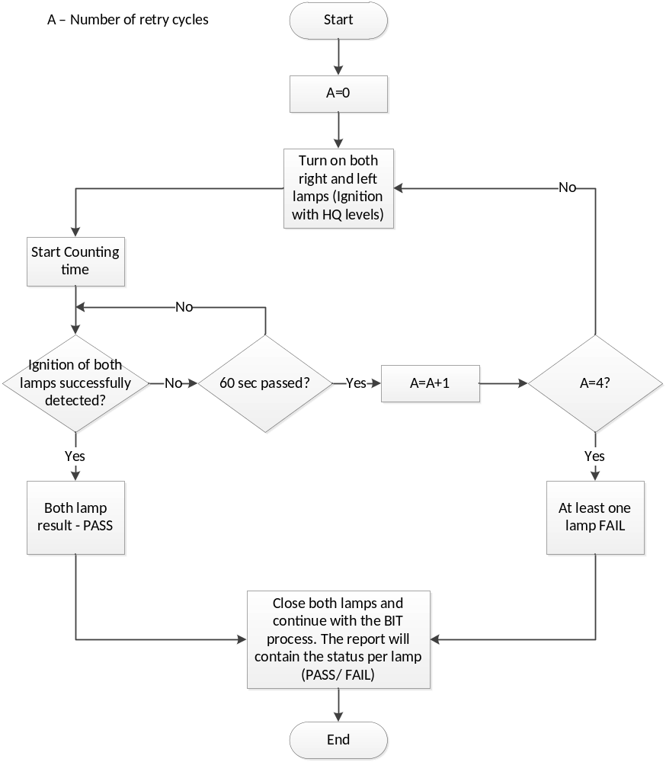
    - Voltages
      - Add new BIT test of defined system voltages.
      - There are 4 potential new voltages we can read their output voltages and define pass/fail criteria. Currently, in the Triplex we are using two of those options for the two additional height thermistors therefore we are able to implement only two new voltages. When a new OHDB board will be implemented, the other two voltages could be implemented as well.
      - Selected Voltages for the test:
        - VPP Power Supply (AN21; P0.4) – Main 40V for the heads.
        - VDD Power Supply (AN23; P0.6) – Voltage for the height thermistors.
        - None selected voltages: 24V and VCC (will be implemented in the future).
      - Pass/Fail criteria for all four voltages: ±5%.
    - Vacuum test adaptation for the current test:
      - It is possible to read the vacuum pump voltage via the SW.
Add the vacuum pump voltage to the current BIT vacuum test. The current test is testing the vacuum level in cm/H2O.
In the BIT report, in the vacuum section, two different rows will report the cm/H2O and the pump voltage. Pass result will be defined only when both test were passed.
      - The pump voltage Pass/Fail criteria is 5.3V ±0.2V.
      - The BIT will contain the current voltage as well, no matter if the result is Pass / Fail.

